select e.last_name as Nume_PM, d.department_name as Departament_PM, e.salary as Salariu_PM, j.job_title as Nume_Job_PM

from employees e, departments d, jobs j

where e.department_id = d.department_id(+)

and e.job_id = j.job_id

and (e.salary, e.commission_pct) in (select salary, commission_pct

from employees

where department_id in (select department_id

from departments

where location_id in (select location_id

from locations

where lower(city) = 'oxford')));

-- am selectat datele cerute din tabelele employees, departments si jobs care au fost notate cu cate o litera;

-- am realizat un outer join pe baza department_id-ului pentru afisarea completa a angajatilor, apoi inca un join pe baza job_id-ului;

-- cu ajutorul subcererilor, am selectat angajatii al caror salariu si comision coincid cu salariul si comisionul

-- unui angajat din Oxford;

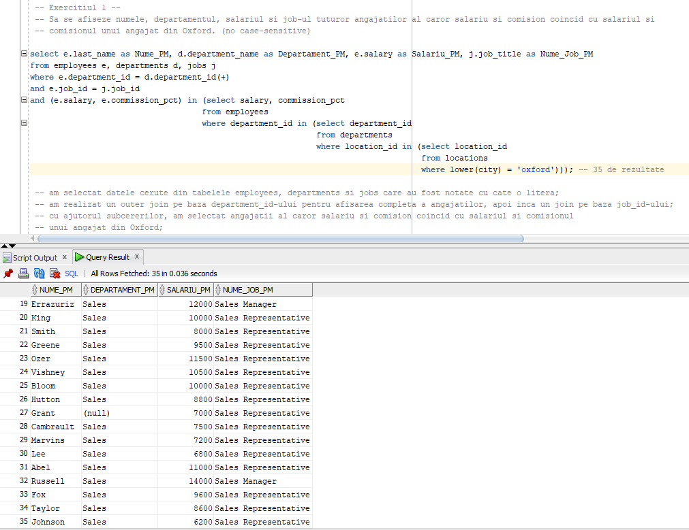

select e.employee_id as ID_Angajat_PM, e.last_name as Nume_PM, e.first_name as Prenume_PM, e.salary as Salariu_PM

from employees e, jobs j

where e.job_id = j.job_id

group by e.last_name, e.salary, e.first_name, e.employee_id

having round(avg(e.salary)) > (select min(round(avg(salary)))

from employees e, jobs j

where e.job_id = j.job_id

group by e.job_id);

-- am selectat datele cerute din tabelele employees si jobs notandu-le corespunzator;

-- am realizat un join intre aceste 2 tabele pe baza job_id-ului, grupandu-le conform coloanelor selectate;

-- am folosit clauza having pentru a verifica ce angajati au salariul mai mare decat cea mai mica medie reala pentru fiecare job.

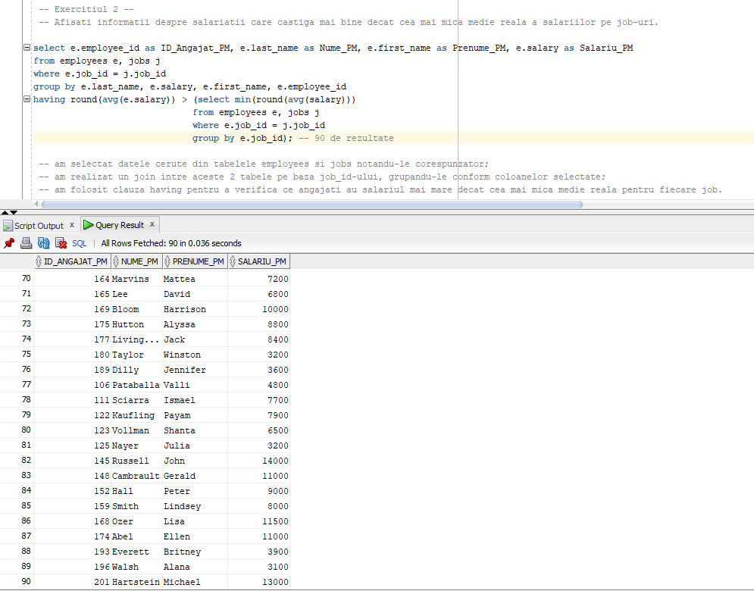

select e.last_name as Nume_PM, e.first_name as Prenume_PM, e.job_id as ID_Job_PM, e.salary as Salariu_PM, aux.media_reala as Medie_Reala_PM

from employees e, (select job_id job, avg(salary) media_reala

from employees

group by job_id) aux

where e.job_id = aux.job

and e.salary > aux.media_reala

order by 4;

-- am selectat datele cerute din tabela employees si cu ajutorul subcererii prin care am aflat media reala pentru fiecare job;

-- am realizat un join pe baza job_id-ului si am pus conditia ca salariul sa fie mai mare decat media reala.

